Student Name: Sri Charan Karri

Student ID: 21083133

7PAM2000 Applied Data Science 1

ASSIGNMENT 1: VISUALISATION

Table of Contents

Question 1 2

Plot 1: 3

Question 2 4

Plot 3 4

Plot 3 5

References 6

# Question 1

Produce a line plot showing multiple lines with proper labels and legend. Describe what conclusions you can draw from this plot.

As we all know water, sanitation, and hygiene(wash) are most important fundamental determinants of wellbeing and health.

That is why, I have chosen the data that was depend on the drinking water and Sanitation based on the rural urban and total area of the United Kingdom of Great Britain and Northern Ireland of 2018 to 2020.

Drinking water and sanitation play a vital role in the humans’ lives and drinking water quality is important that are used by households for drinking, personal hygiene, cooking and other domestic uses.

Sanitation refers to waste discharge from human contact. People must have to improve the process of managing of the waste efficiently that cannot produce any bacteria or other harmful thing that can affect the humans and animals’ life badly.

**Link of the dataset: -**[JMP (washdata.org)](https://washdata.org/data/household#!/table?geo0=country&geo1=GBR)

**Link of the github repository: -**

<https://github.com/Charan-077/visualization_assignment>

## Plot 1:

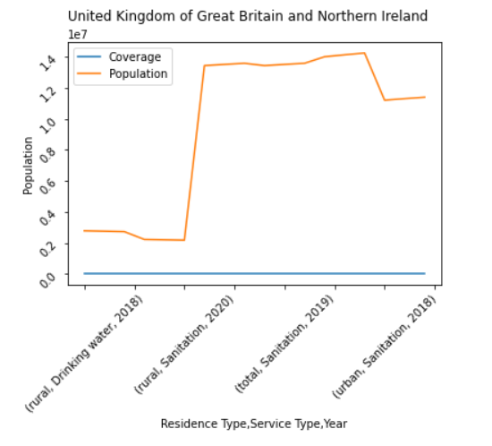

Figure : Graph 1

The above line graph describes the information population of both the rural, urban, and total area of the United Kingdom of Great Britain and Northern Ireland details of drinking water and Sanitation in the area. Fluctuation shows the difference in the improving of drinking water and sanitation.

The orange line shows the population based on the year as well as residence type and service type.

# Question 2

Produce graphs using two other visualisation methods. Explain why you picked this type of graph and describe what conclusions you can draw.

## Plot 2

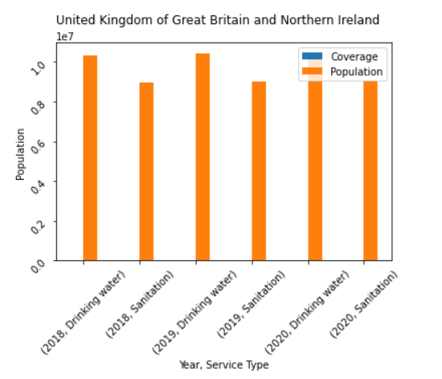

Figure : Graph 2

This is the second graph of this document and this will show the data based on the year and service type of the population of United Kingdom of Great Britain and Northern Ireland. I used the bar graph that would help me to easily view the statistics of the data Frame. The graph displays the Coverage and population based on the drinking water and Sanitation based on the year 2018,2019 and 2020 as well. In this graph, you have seen the coverage was shown in the blue colour but is cannot display in the graph because the coverage is the constant type of values that cannot display with the population (Horvath, 2022).

## Plot 3

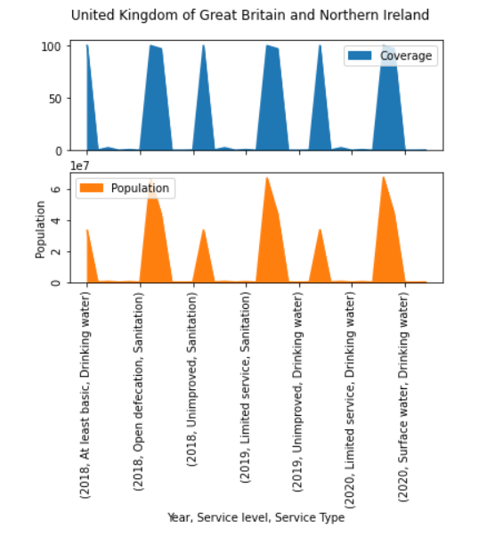

Figure : Graph 3

In the third graph we use the area graph to display the population and coverage based on the service level and service Type depend on the year. Area graph help to easily seen the fluctuation occurs in the graph of population and coverage. The United Kingdom of Great Britain and Northern Ireland improve the drinking water and sanitation condition in their area (M, 2022).

# References

Horvath, R. (2022). Using pandas and python to explore your dataset, Real Python. Real Python. [Online]. Available at: https://realpython.com/pandas-python-explore-dataset/ (Accessed: November 9, 2022).

M, R. (2022). What is Matplotlib in python? how to use it for plotting?, ActiveState. [Online]. Available at: https://www.activestate.com/resources/quick-reads/what-is-matplotlib-in-python-how-to-use-it-for-plotting/ (Accessed: November 9, 2022).